Mount Sinai Downtown RESIDENCY IN URBAN FAMILY medicine
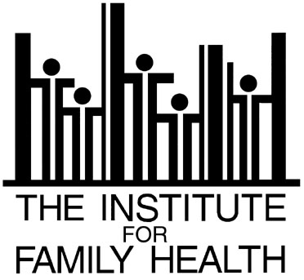

Academic Integrative Family Medicine Fellowship

APPLICATIONS OPEN FOR SUBMISSION SEPTEMBER 6, 2016

Please copy, complete and submit the application electronically to Dr. Raymond Teets, rteets@insitute.org, along with your CV. In addition, please write 1-2 paragraphs to answer each of the following questions:

- Where would you like to see yourself professionally in 5-10 years?

- Why are you interested in integrative medicine?

Application

Name:

Email address: Telephone:

Mailing address:

Degrees (list all):

Date Received: Institution:

Other relevant professional work:

Current licensure and boards:

Professional membership(s):

Presentations (i.e. grand rounds or professional or community organizations):

Involvement and/or experience in CAM and/or Integrative Medicine:

Languages:

Professional references (department chair, program director):
(Send letters as directed above)

Name: Phone:
Email: Position:

Name: Phone:
Email: Position:

Name: Phone:
Email: Position:

