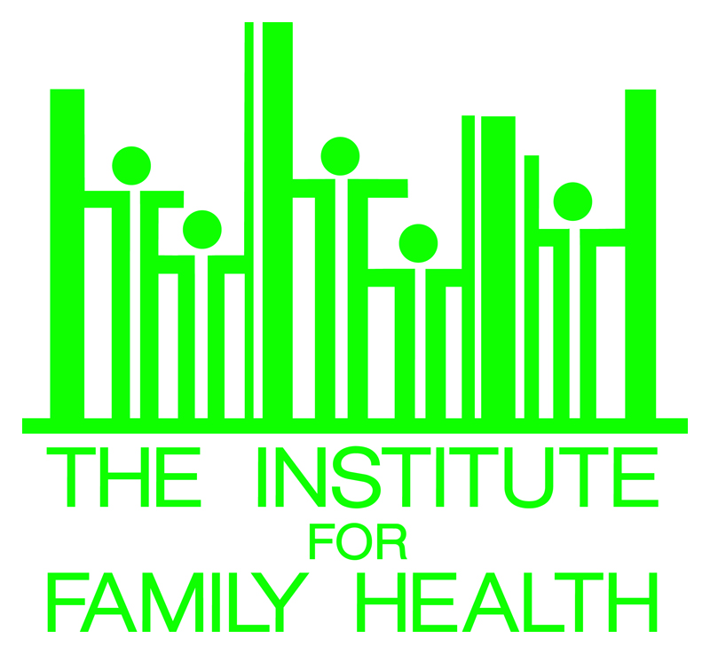

the institute for family health

preliminary questionnaire for proposed research

Please complete this document to inform the Institute of your proposed research. Answers may be brief. Forms must be submitted at least one week prior to the Research Committee meeting. All proposed studies must have a Research Committee approval letter before being submitted to the IRB.

Date: ____________________

Contact Name: ____________________ Title: ___________________________

Contact Phone Number: __________________________________________________

Contact E-Mail:_________________________________________________________

Title of Project:

Expected duration of project: from: ______________ to: ______________

Principal Investigator (if different from contact):

Proposed Practice Site(s):

Summary of Project

Select your research category:

Racial and ethnic health disparities
Patient-centered care
Health information technology
Integration of mental health care and primary care
Women’s health
Other

Have you conducted a literature review? _____ Yes _____ No

Please state your research questions and significance:

Describe how this project supports the Institute’s mission:

Describe your proposed research methods. Please be clear about how the study will be operationalized. Who will be doing the research and how will it be funded?:

Describe any anticipated Institute support:

Is this project funded? _____ Yes _____ No
Funder Name:
Funder Amount:

Supervisor Name (if applicable):

Supervisor Approval:

Principal Investigator Signature (if different):

Please return to:

Monica Gagnon
Institute for Family Health
16 East 16th Street
New York, NY 10003
mgagnon@institute2000.org

